Q 1 ADDITION OF 2 NOS

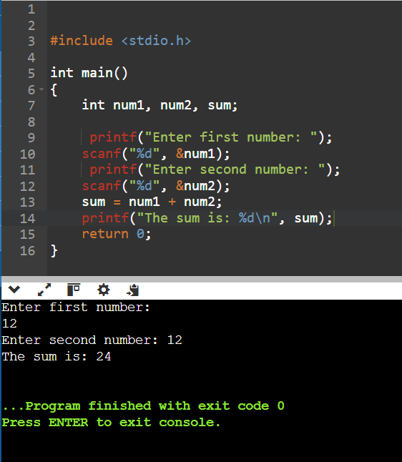

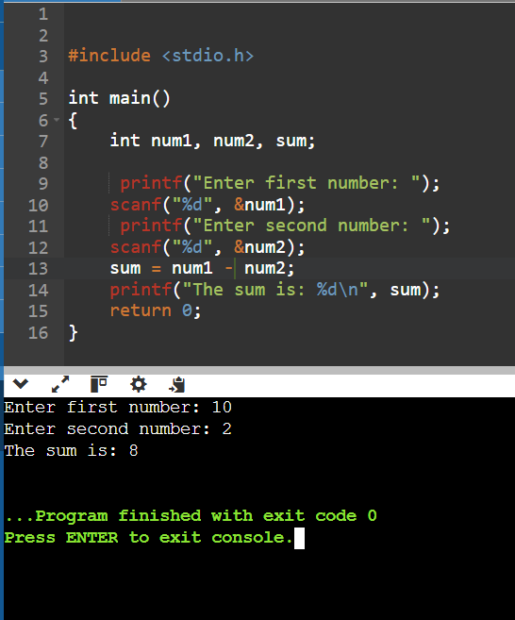Q 2 SUBSTRACTION OF 2 NOS

Q 3 MULTIPLICATION OF 2 NOS

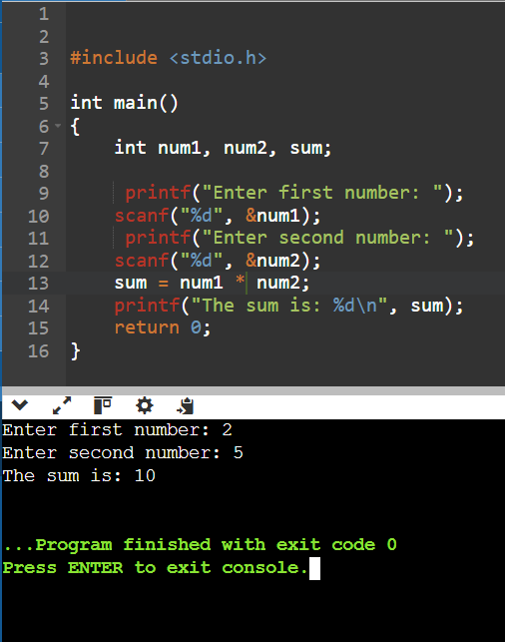

Q 4 DIVISION OF 2 NOS

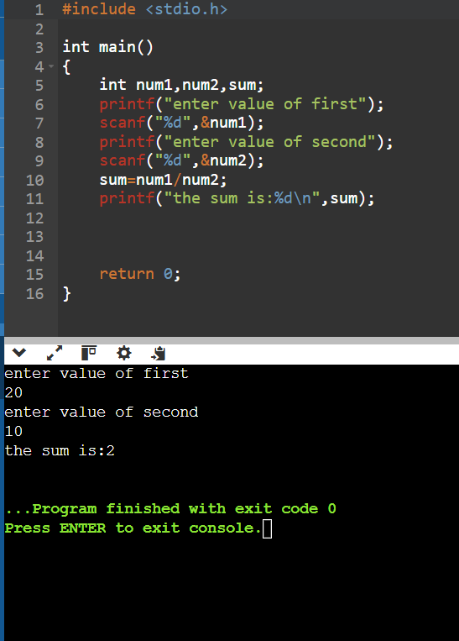

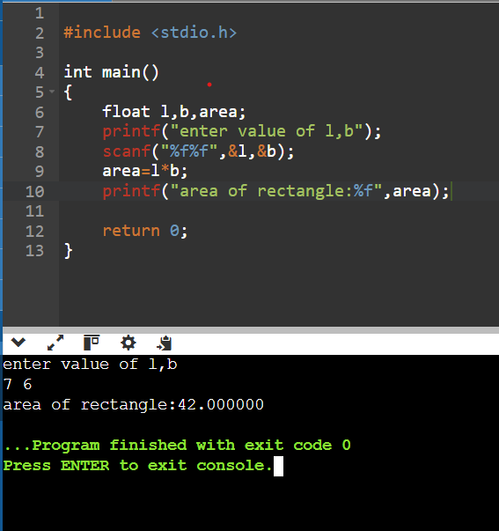Q 5 AREA OF TRIANGLE

Q 6 AREA OF RECTANGLE



Q 7 CALCULATE KINETIC ENERGY

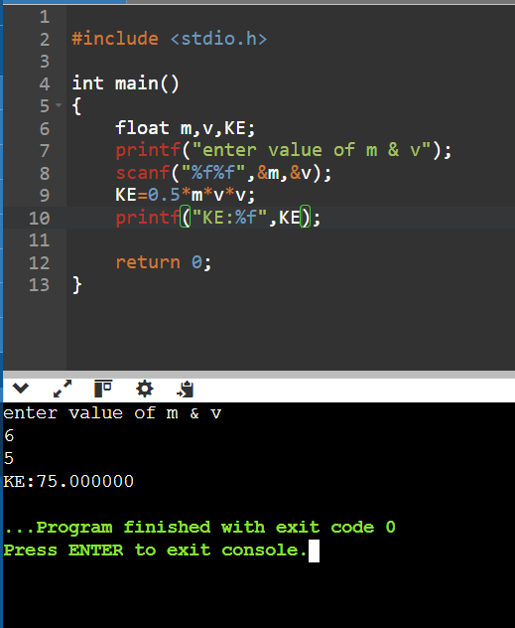

Q 8 CALCULATE POTENTIAL ENERGY  
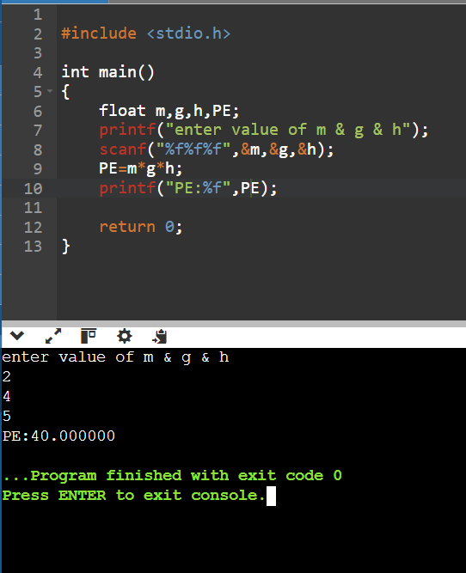

Q 9 CALCULATE SURFACE AREA AND VELOCITY  
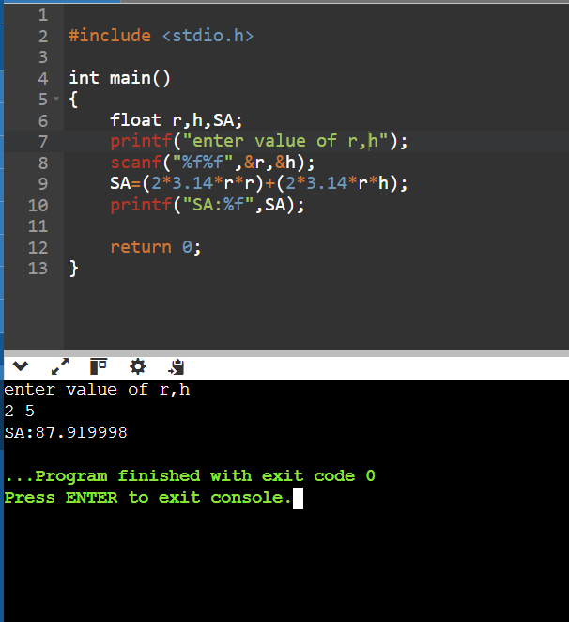

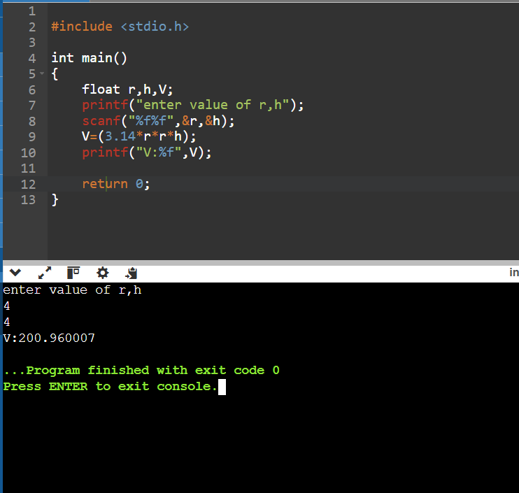

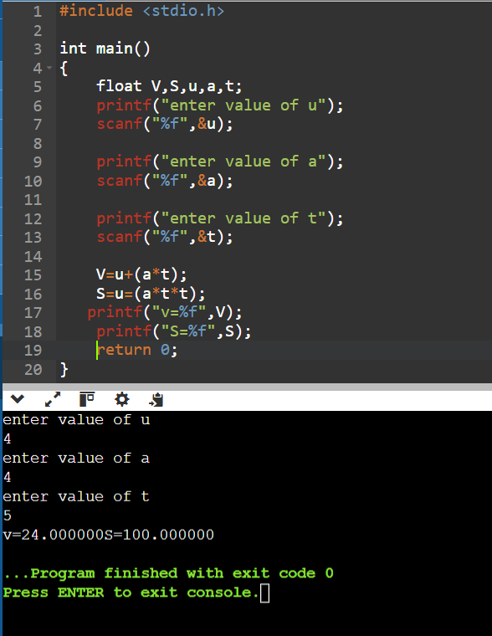Q 11 TO FIND VELOCITY AND DISTANCE

Q 12 TO FIND AREA AND PARIMETER OF RING

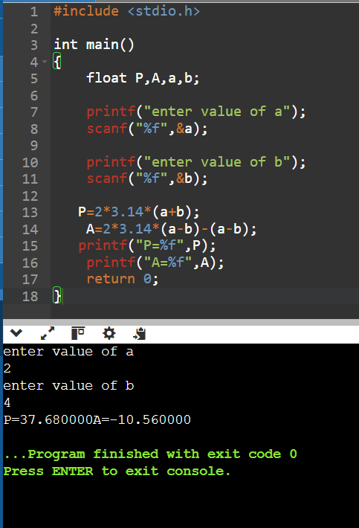

Q 13 TO FIND SURFACE AREA AND VOLUME OF CUBOID

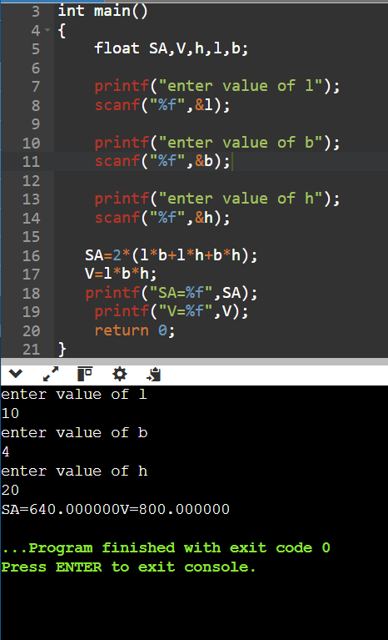

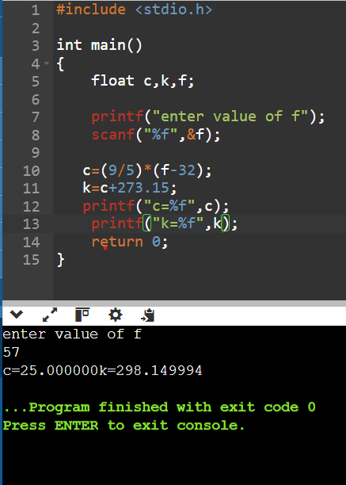Q 14 TO FIND TEMPERATURE IN C AND KELVIN

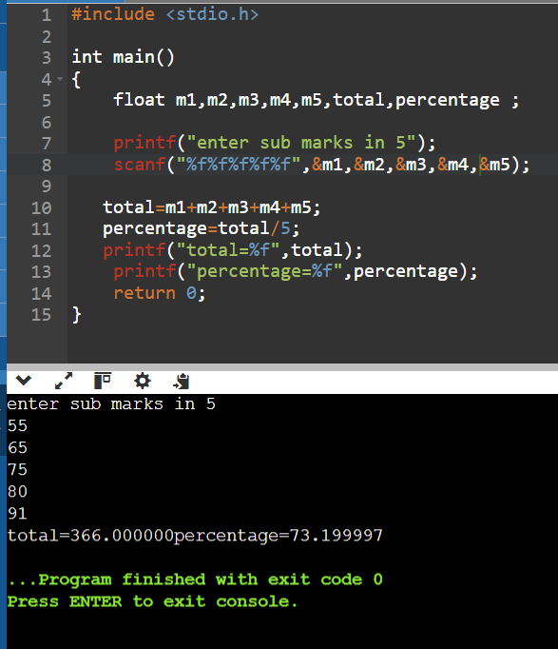Q 15 ACCEPT 5 SUBJECT FRM USER AND CALCULATE TOTAL AND PERCENTAGE

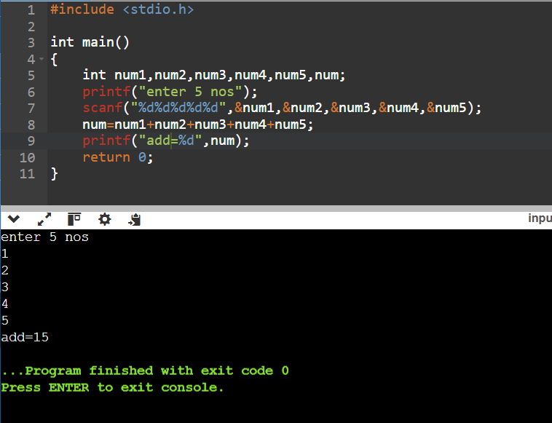Q16 ADDITION OF 5 NUMS

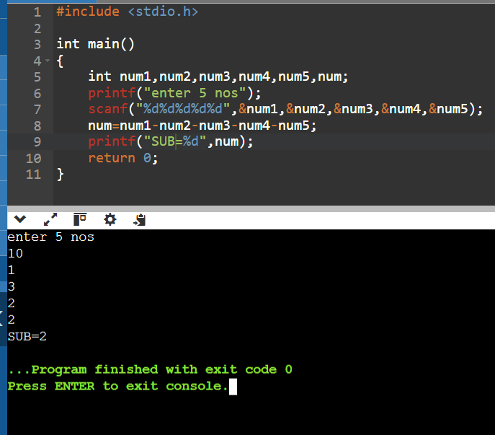Q17 SUB OF 5 NOS

Q18 MULTIPLICATION OF 5 NOS

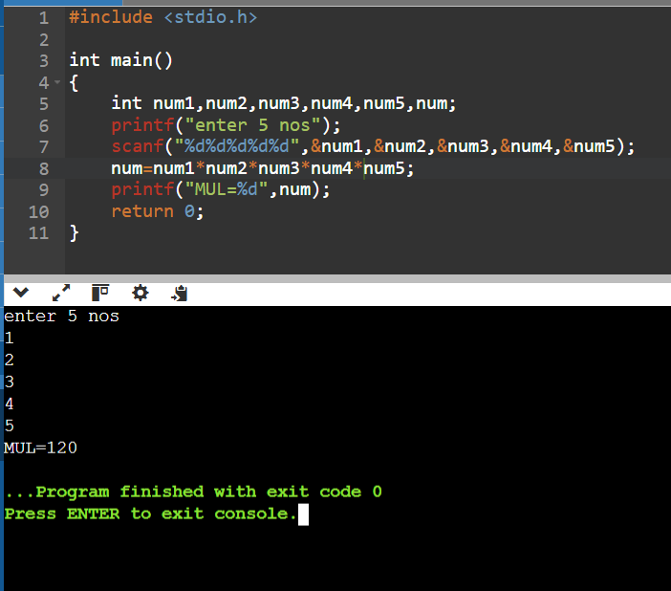

Q19 SWAPPING USING BITWISE OPERATOR

